**NAME** :- Manish Shashikant Jadhav

**UID** :- 2023301005.

**BRANCH** :- Comps -B. **BATCH:** B.

**EXPERIMENT 2:** To create a database and populate using SQL commands (With Constraint)

* Data Definition Language- Create, Alter, Drop, Rename.
* Data Manipulation Language- Insert, Update, Delete, Select.
* Constraints-Not Null, Unique Key, Primary Key, Foreign Key, Check, Dropping a Constraint.

**SUBJECT** :- DBMS (DATABASE MANAGEMENT SYSTEM)

**TABLE NO.1: NGO-**

create database elderlycare;

use elderlycare;

create table ngo(id int primary key, location varchar(20), noof_workers int, care_fund varchar(100), contribution varchar(100)

);

insert into ngo(id, location, noof_workers, care_fund, contribution) values (1, 'Mahad', '20', 100000, 'Healthcare'),

(2, 'Mumbai', '15', 1000000, 'Justice'),

(3, 'Pune', '30', 50000, 'Provide Meal'),

(4, 'Delhi', '10', 100000, 'Non-Maleficence'),

(5, 'Andheri', '10', 150000, 'Healthcare'),

(6, 'Thane', '8', 200000, 'Provide Meal'),

(7, 'Mumbai', '30', 380000, 'Healthcare'),

(8, 'Ayodhya', '40', 128000, 'Justice'),

(9, 'Pune', '20', 500000, 'Healthcare'),

(10, 'Gurugram', '30', 1000000, 'Provide Meal');

select * from ngo;

alter table ngo rename to ngos;

describe ngos;

alter table ngos modify contribution varchar(20);

describe ngos;

alter table ngos change column noof_workers no_of_workers int(11);

describe ngos;

alter table ngos add contact varchar(255);

decscribe ngos;

insert into ngos(id, location, no_of_workers, care_fund, contribution)

values (11, 'Kalyan', '7', 40000, 'Provide Meal');

select * from ngos;

select * from ngos where contribution='Provide Meal';

select * from ngos where care_fund between 100000 and 500000;

update ngos set location='Vrindavan', contribution='Non-Maleficence' where id=7;

select * from ngos;

delete from ngos where id=11;

select * from ngos;

select count(location) from ngos;

select max(care_fund) from ngos;

select min(care_fund) from ngos;

* **View Table:**

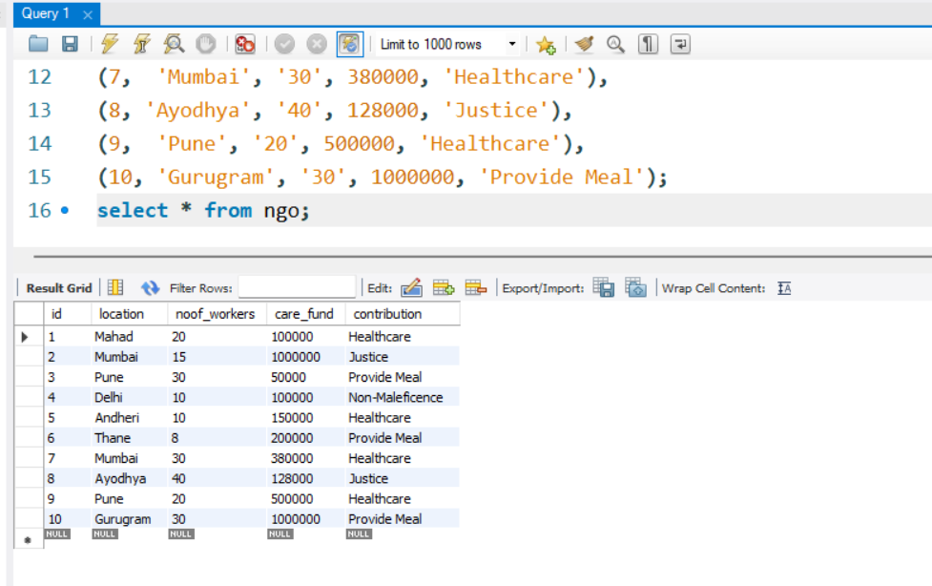

* **Rename Table name:**

alter table ngo rename to ngos;

describe ngos;

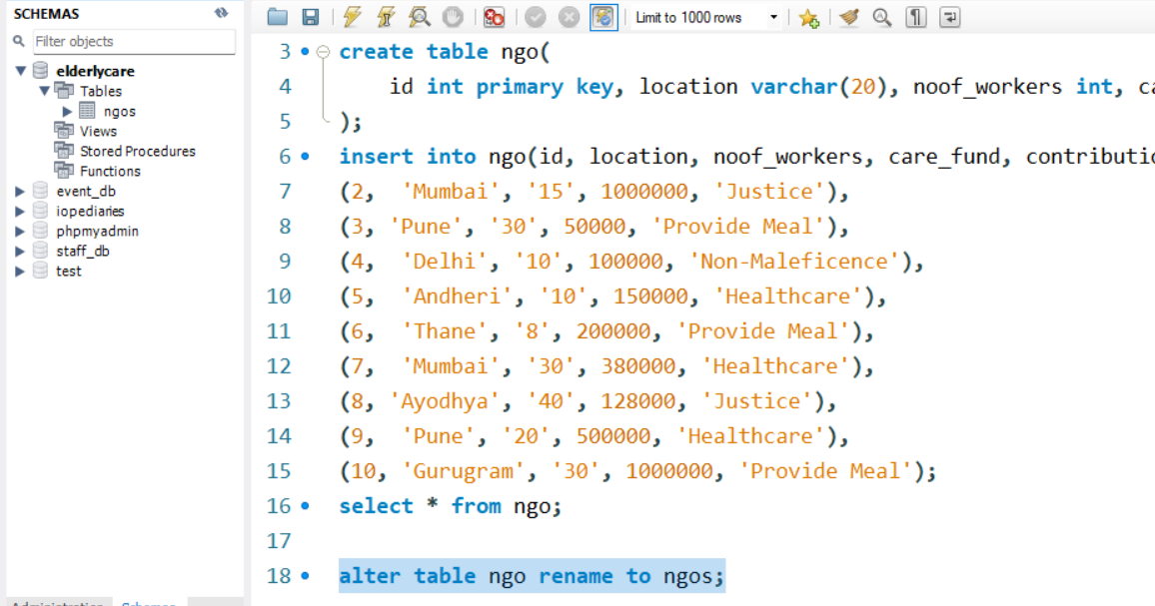

* **Modify data value:**

alter table ngos modify contribution varchar(20);

describe ngos;

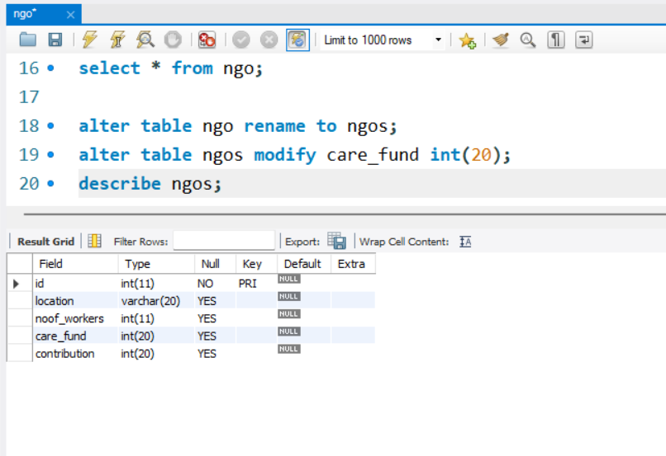

* **Change column name:**

alter table ngos change column noof_workers no_of_workers int(11);

describe ngos;

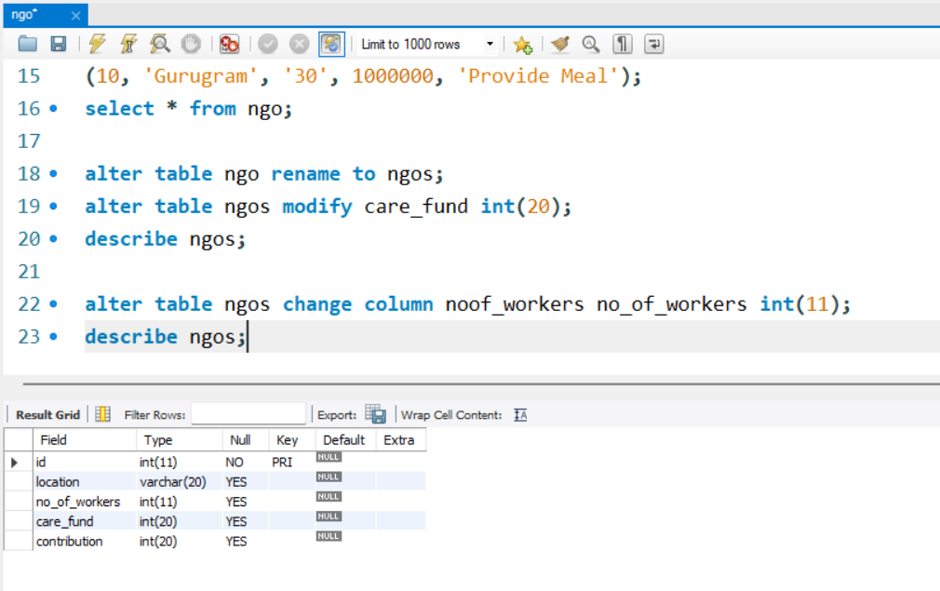

* **Add New Column:**

alter table ngos add contact varchar(255);

describe ngos;

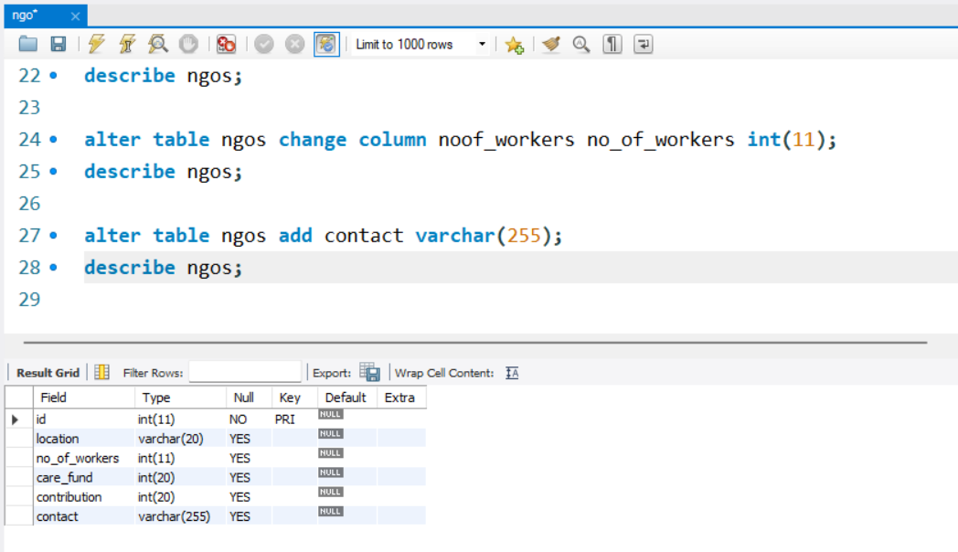

* **Insert new values:**

insert into ngos(id, location, no_of_workers, care_fund, contribution) values (11, 'Kalyan', '4', 40000, 'Provide Meal');

select * from ngos;

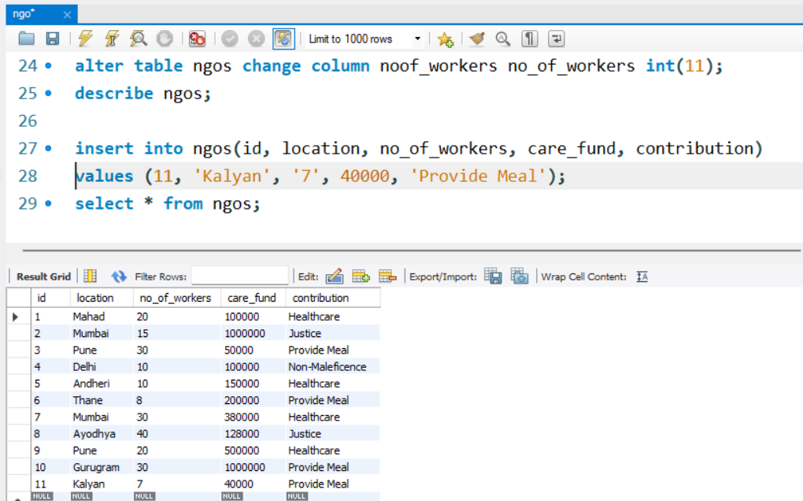

* **Select Where Command & Select Between Command:**

select * from ngos where contribution='Provide Meal';

select * from ngos where care_fund between 100000 and 500000;

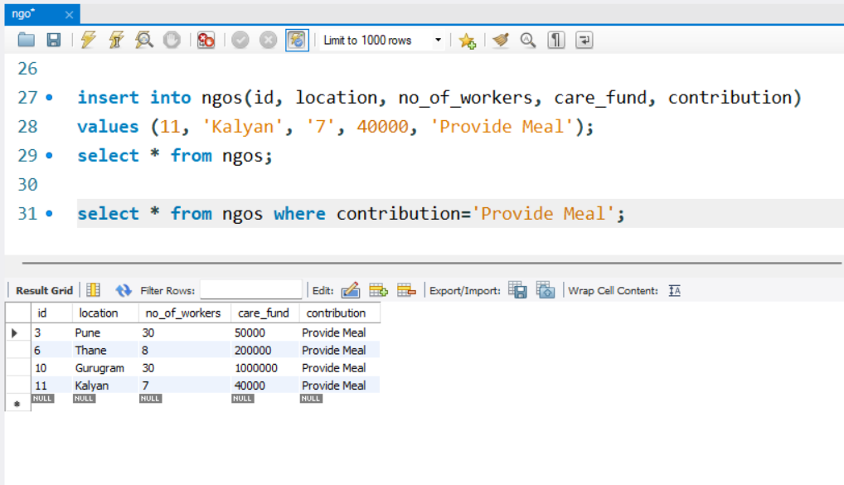

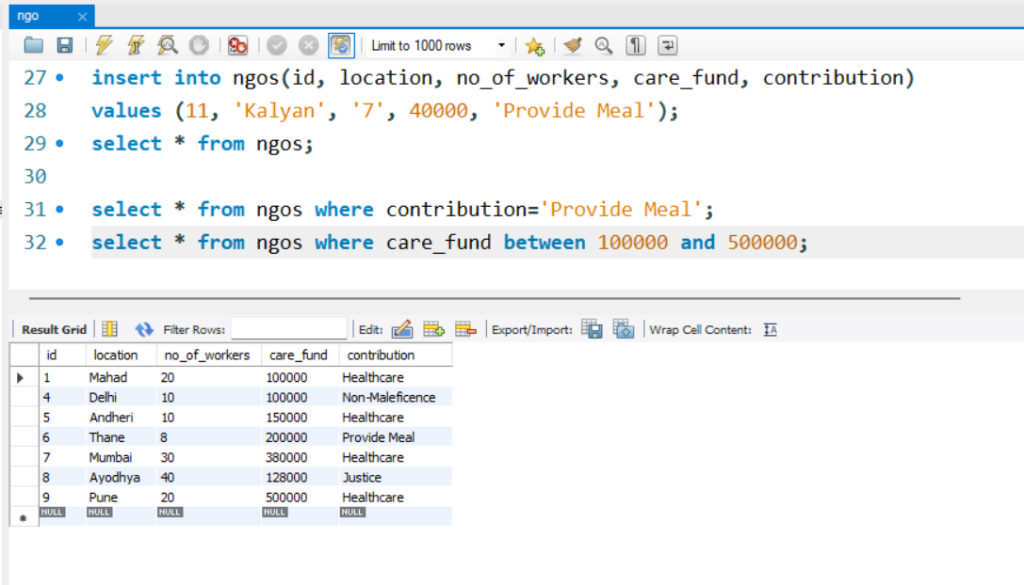

* **Update Values:**

update ngos set location='Vrindavan', contribution='Non-Maleficence' where id=7;

select * from ngos;

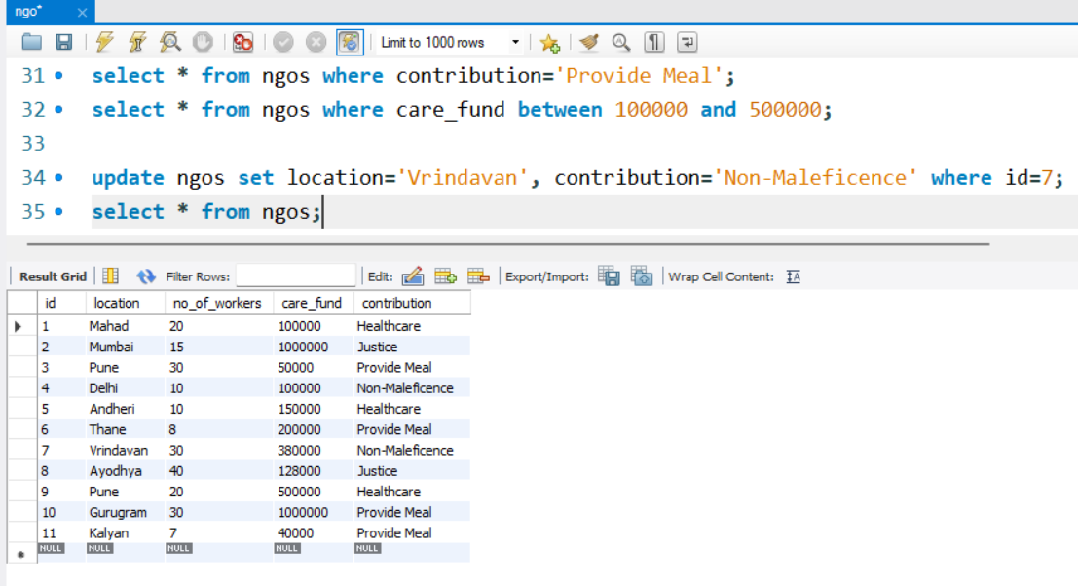

* **Delete row:**

delete from ngos where id=11;

select * from ngos;

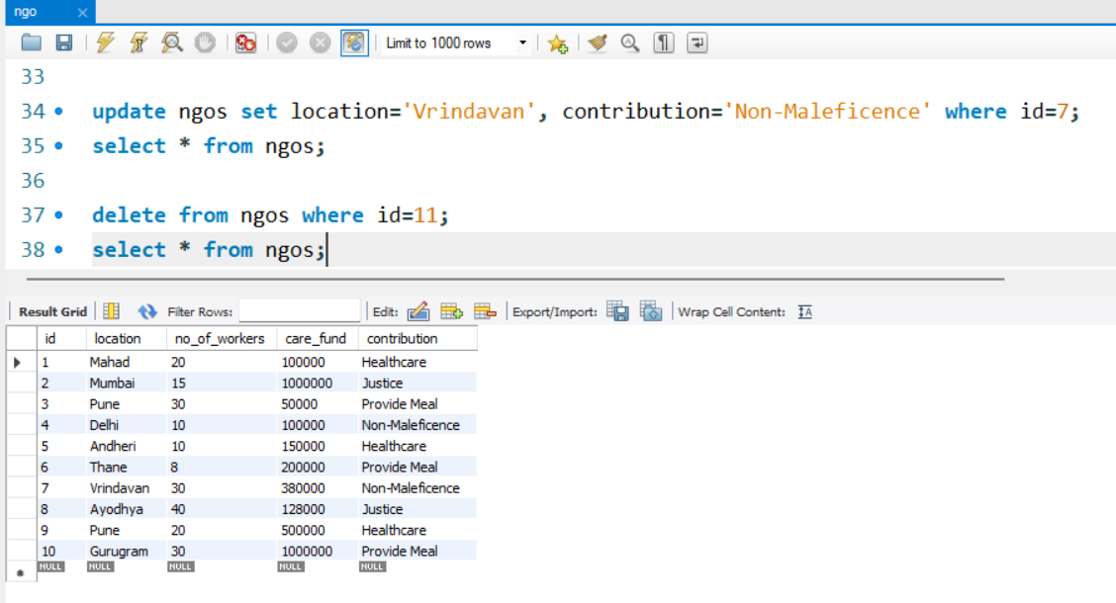

* **Count() function:**

select count(location) from ngos;

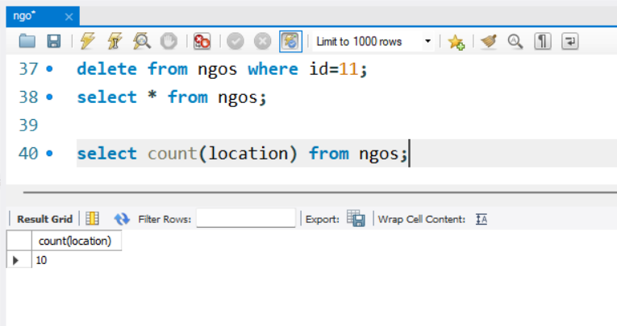

* **MAX() function:**

select max(care_fund) from ngos;

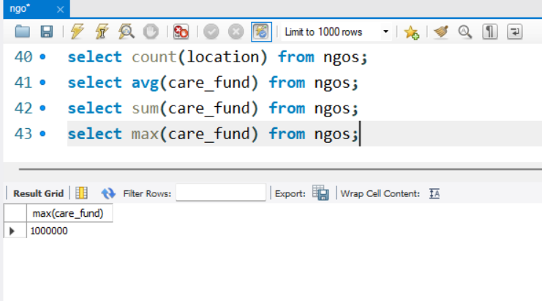

* **MIN() function:**

select min(care_fund) from ngos;

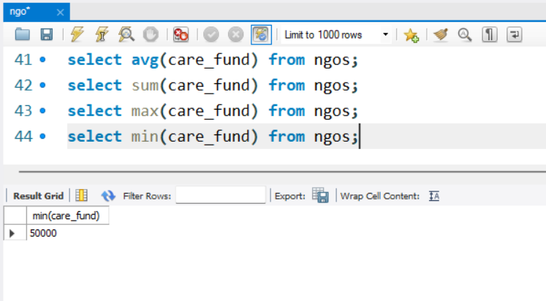

**TABLE NO.2: Senior Citizen-**

use elderlycare;

create table seniorcitizen(

sid int primary key not null, name varchar(100), dob varchar(12), age int, gender varchar(5), address varchar(20), martial_status varchar(10), time_slots varchar(25),

health_issue varchar(100), intrests varchar(100)

);

insert into seniorcitizen(sid, name, dob, age, gender, address, martial_status, time_slots, health_issue, intrests) values (1, 'Krunal', '1954-18-05', 69, 'M', 'Kolad', 'Single',

'12pm to 6pm', 'Lower Back Injury', 'Back Massage'),

(2, 'Om', '1956-20-09', 67, 'M', 'Panvel', 'Married', '5pm to 9pm', 'Knee Pain', 'Legs Massage'),

(3, 'Saee', '1950-03-02', 73, 'F', 'Panvel', 'Married', '6pm to 10pm', 'Migrane', 'Head Massage'),

(4, 'Vishakha', '1960-29-07', 63, 'F', 'Mahad', 'Single', '2pm to 10pm', 'Vasculities', 'Legs Massage'),

(5, 'Apurva', '1950-13-02', 73, 'F', 'Mahad', 'Single', '8pm to 11pm', 'Hypertension Headache', 'Full Body Massage'),

(6, 'Vishesh', '1948-03-12', 75, 'M', 'Thane', 'Married', '3pm to 8pm', 'Chest Pain', 'Full Body Massage'),

(7, 'Shrijal', '1957-03-02', 66, 'F', 'Thane', 'Single', '6pm to 8pm', 'Varicose', 'Full Body Massage'),

(8, 'Sejal', '1954-24-08', 69, 'F', 'Matunga', 'Married', '6pm to 9pm', 'Sinus', 'Head Massage'),

(9, 'Jay', '1945-27-03', 78, 'M', 'Kalyan', 'Single', '4pm to 8pm', 'Joints Pain', 'Legs Massage'),

(10, 'Harshal', '1965-03-02', 58, 'M', 'Mahad', 'Married', '6pm to 10pm', 'Upper Back Injury', 'Back Massage');

select * from seniorcitizen;

alter table seniorcitizen rename to seniorcitizens;

describe seniorcitizens;

alter table seniorcitizens modify gender char(3);

describe seniorcitizens;

alter table seniorcitizens change column address location varchar(20);

describe seniorcitizens;

alter table seniorcitizens add contact varchar(25);

describe seniorcitizens;

insert into seniorcitizens(sid, name, dob, age, gender, location, martial_status, time_slots, health_issue, intrests, contact) values (11, 'Swayam,', '1954-19-05', 69, 'M', 'Thane', 'Single',

'12pm to 6pm', 'Lower Back Injury', 'Back Massage', '123456789');

select * from seniorcitizens;

delete from seniorcitizens where sid=11;

select * from seniorcitizens;

select * from seniorcitizens where intrests='Full Body Massage';

select * from seniorcitizens where age between 70 and 80;

update seniorcitizens set location='Vrindavan', health_issue='Hypertension Headache' where sid=9;

select * from seniorcitizens;

select count(gender) from seniorcitizens;

select max(age) from seniorcitizens;

select min(age) from seniorcitizens;

* **View Table:**

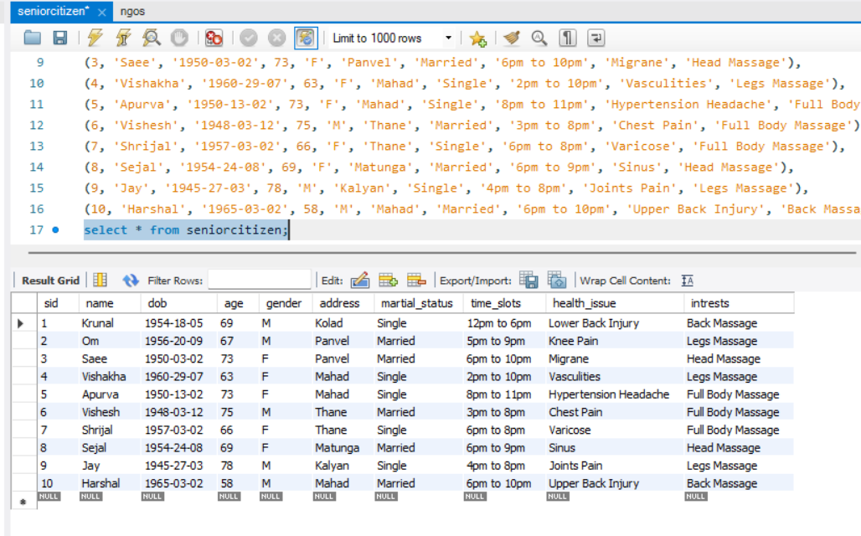

* **Rename Table:**

alter table seniorcitizen rename to seniorcitizens;

describe seniorcitizens;

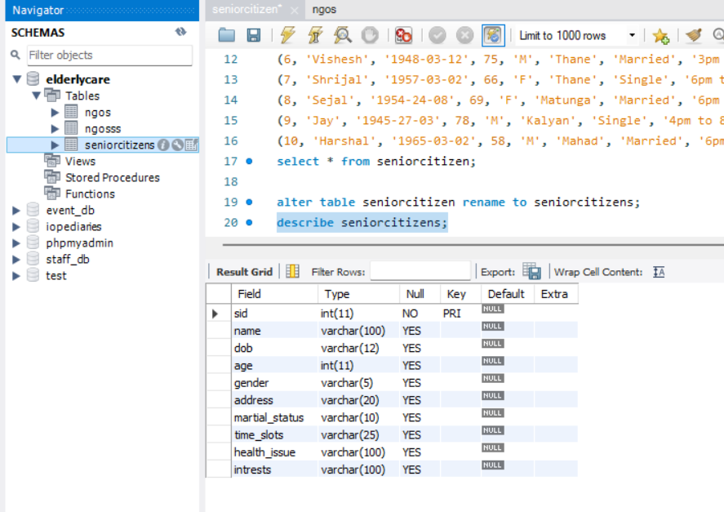

* **Modify Data Type:**

alter table seniorcitizens modify gender char(3);

describe seniorcitizens;

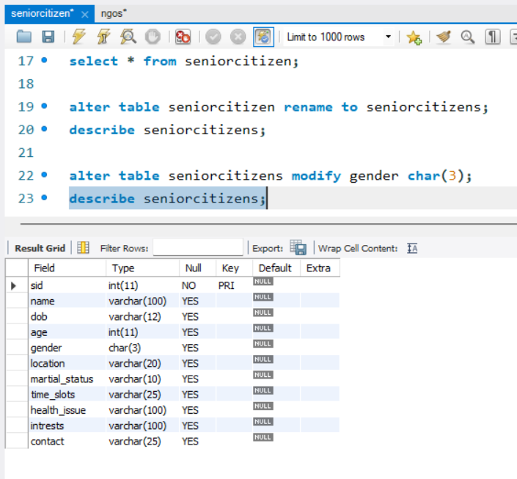

* **Modify Column Name:**

alter table seniorcitizens change column address location varchar(20);

describe seniorcitizens;

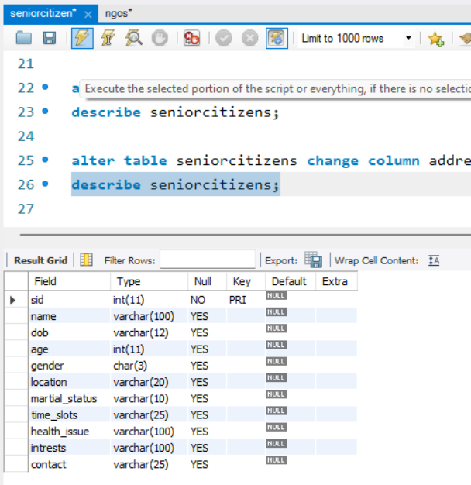

* **Add New Column:**

alter table seniorcitizens add contact varchar(25);

describe seniorcitizens;

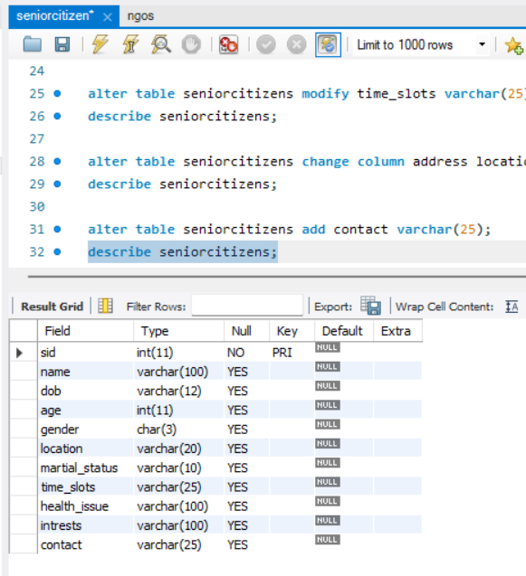

* **Insert New Value:**

insert into seniorcitizens(sid, name, dob, age, gender, location, martial_status, time_slots, health_issue, intrests, contact) values (11, 'Swayam,', '1954-19-05', 69, 'M', 'Thane', 'Single', '12pm to 6pm', 'Lower Back Injury', 'Back Massage', '123456789');

select * from seniorcitizens;

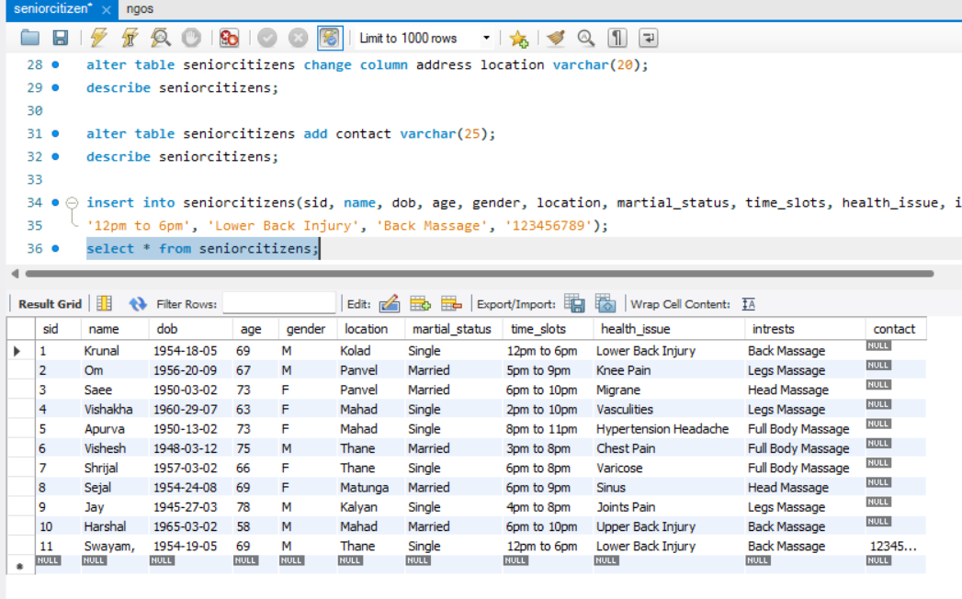

* **Delete Value:**

delete from seniorcitizens where sid=11;

select * from seniorcitizens;

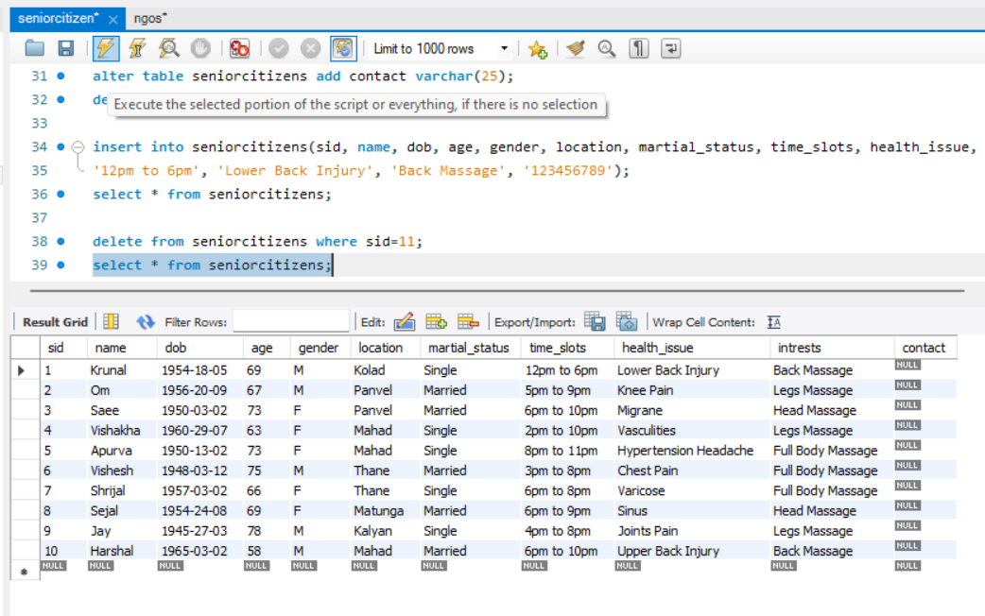

* **Select Where Command:**

select * from seniorcitizens where intrests='Full Body Massage';

select * from seniorcitizens where age between 70 and 80;

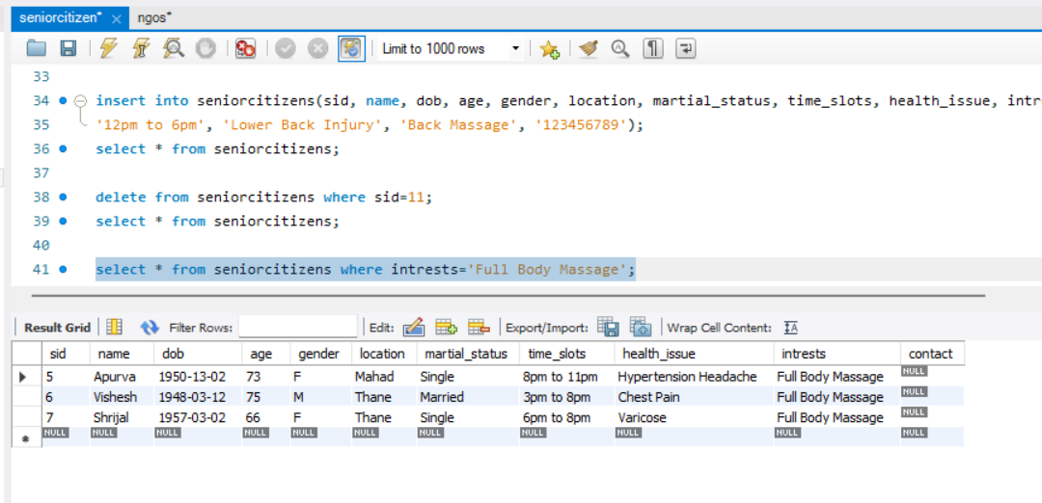

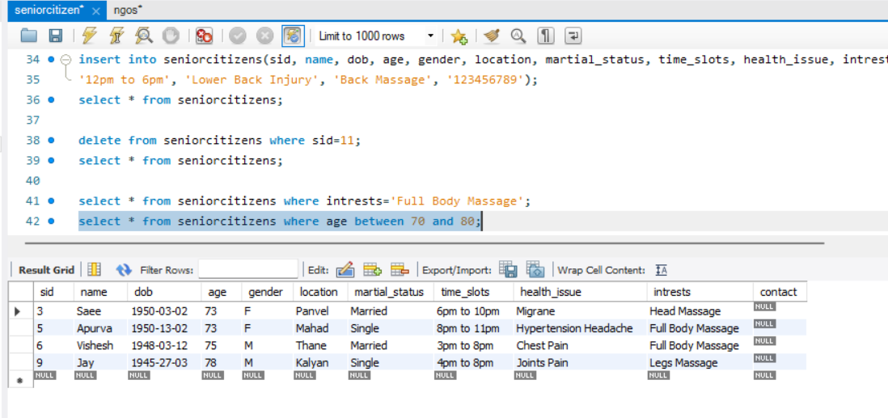

* **Update Values:**

update seniorcitizens set location='Vrindavan', health_issue='Hypertension Headache' where sid=9;

select * from seniorcitizens;

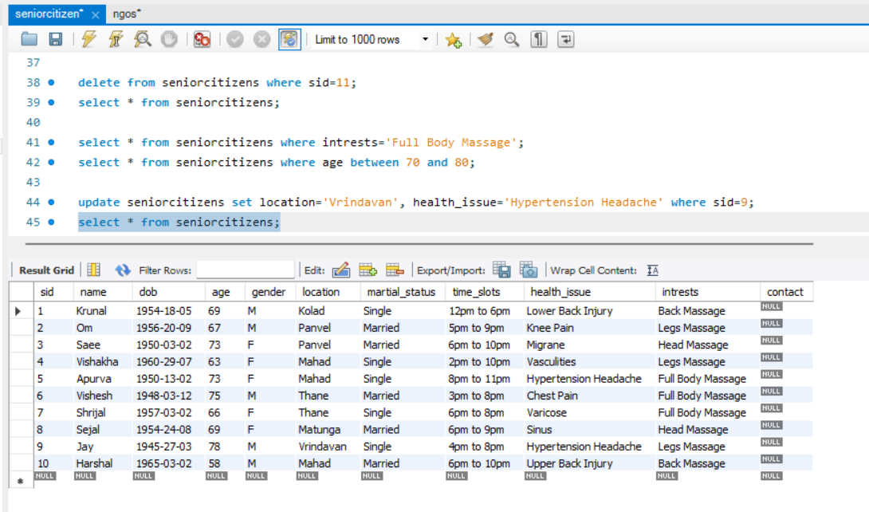

* **Count() function:**

select count(gender) from seniorcitizens;

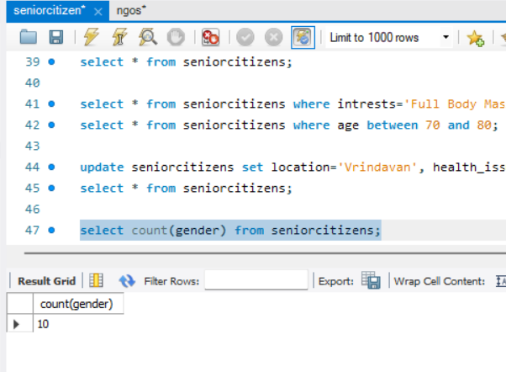

* **Max():**

select max(age) from seniorcitizens;

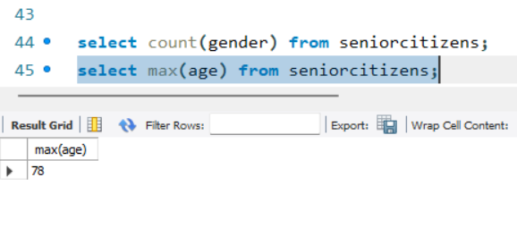

* **Min():**

select min(age) from seniorcitizens;

